Exp No: 7  Date: 19.04.25 | servlet program to store using cookies

AIM :

Write a Servlet program to store a user's preferences (like theme or language) using cookies. Retrieve and display these preferences on subsequent visits.

PROGRAM:

COOKIE.HTML

<!DOCTYPE html>
<html>
<head>
<meta charset="ISO-8859-1">
<title>Cookie</title>
</head>
<body>
<form method="post" action="/sivamurugan/Cookies">
<p>
<label>Theme: </label>
<input type="text" name="Theme">
</p>
<p>
<label>Language: </label>
<select name="language">
<option value="English">English</option>
<option value="Tamil">Tamil</option>
<option value="Hindi">Hindi</option>
</select>
</p>
<button type="submit">Save Preferences</button>
</form>

</body>
</html>

GETCOOKIE.jsp

<!DOCTYPE html>
<html>
<head>
<meta charset="ISO-8859-1">
<title>GET COOKIE </title>
</head>
<body>
<%
Cookie[] cookies = request.getCookies();
if (cookies != null) {
for (Cookie cookie : cookies) {
if ("Theme".equals(cookie.getName())) {
System.out.println(cookie.getName());
out.println(cookie.getValue());
}
else if ("language".equals(cookie.getName())) {
System.out.println(cookie.getName());
out.println(cookie.getValue());
}
}
}

%>
</body>
</html>

Cookie.java

package siva.servlet;

import java.io.IOException;
import javax.servlet.ServletException;
import javax.servlet.annotation.WebServlet;
import javax.servlet.http.Cookie;
import javax.servlet.http.HttpServlet;
import javax.servlet.http.HttpServletRequest;
import javax.servlet.http.HttpServletResponse;

/**
* Servlet implementation class Cookies
*/
@WebServlet("/Cookies")
public class Cookies extends HttpServlet {
private static final long serialVersionUID = 1L;

/**
* @see HttpServlet#HttpServlet()
*/
public Cookies() {
super();
// TODO Auto-generated constructor stub
}

/**
* @see HttpServlet#doGet(HttpServletRequest request, HttpServletResponse response)
*/
protected void doGet(HttpServletRequest request, HttpServletResponse response) throws ServletException, IOException {
String theme = request.getParameter("Theme");
String lang = request.getParameter("language");

Cookie theme_cookie = new Cookie("theme", theme);
Cookie land_cookie = new Cookie("language", lang);
theme_cookie.setMaxAge(60*60);
land_cookie.setMaxAge(60*60);
theme_cookie.setPath("/");
land_cookie.setPath("/");
response.addCookie(theme_cookie);
response.addCookie(land_cookie);

response.sendRedirect("getcookie.jsp");

}

/**
* @see HttpServlet#doPost(HttpServletRequest request, HttpServletResponse response)
*/
protected void doPost(HttpServletRequest request, HttpServletResponse response) throws ServletException, IOException {
// TODO Auto-generated method stub
doGet(request, response);
}

}

OUTPUT:

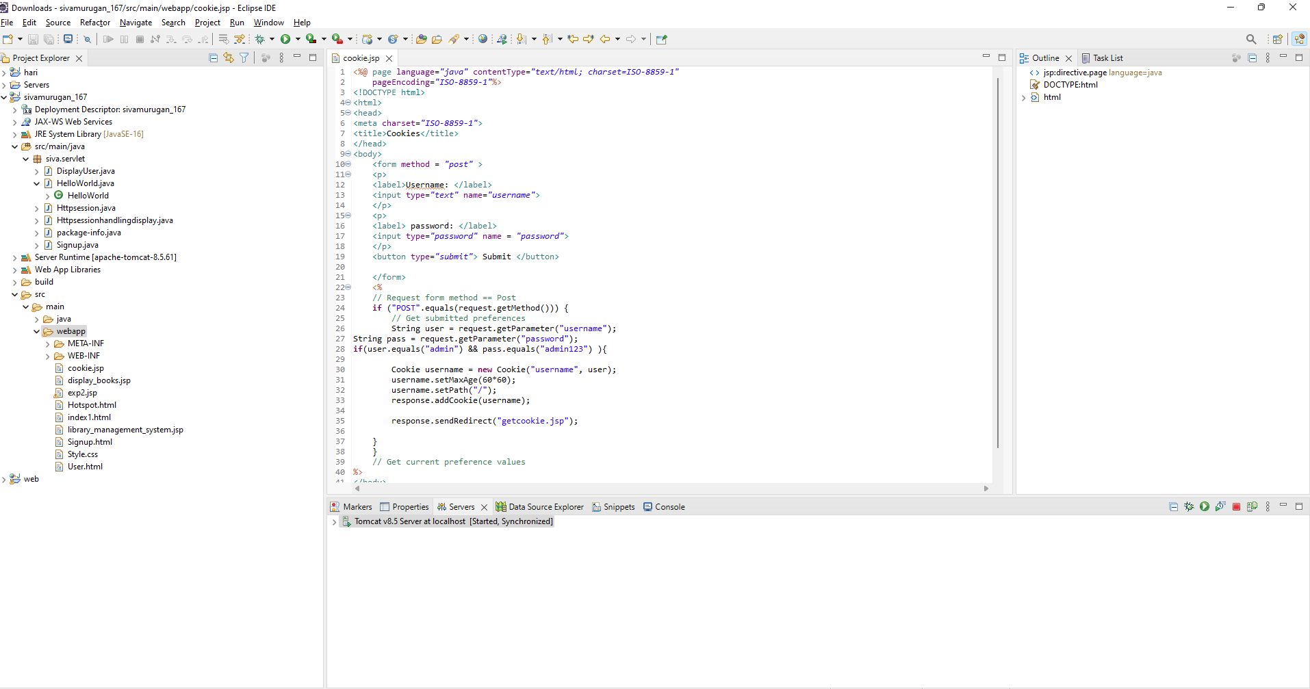

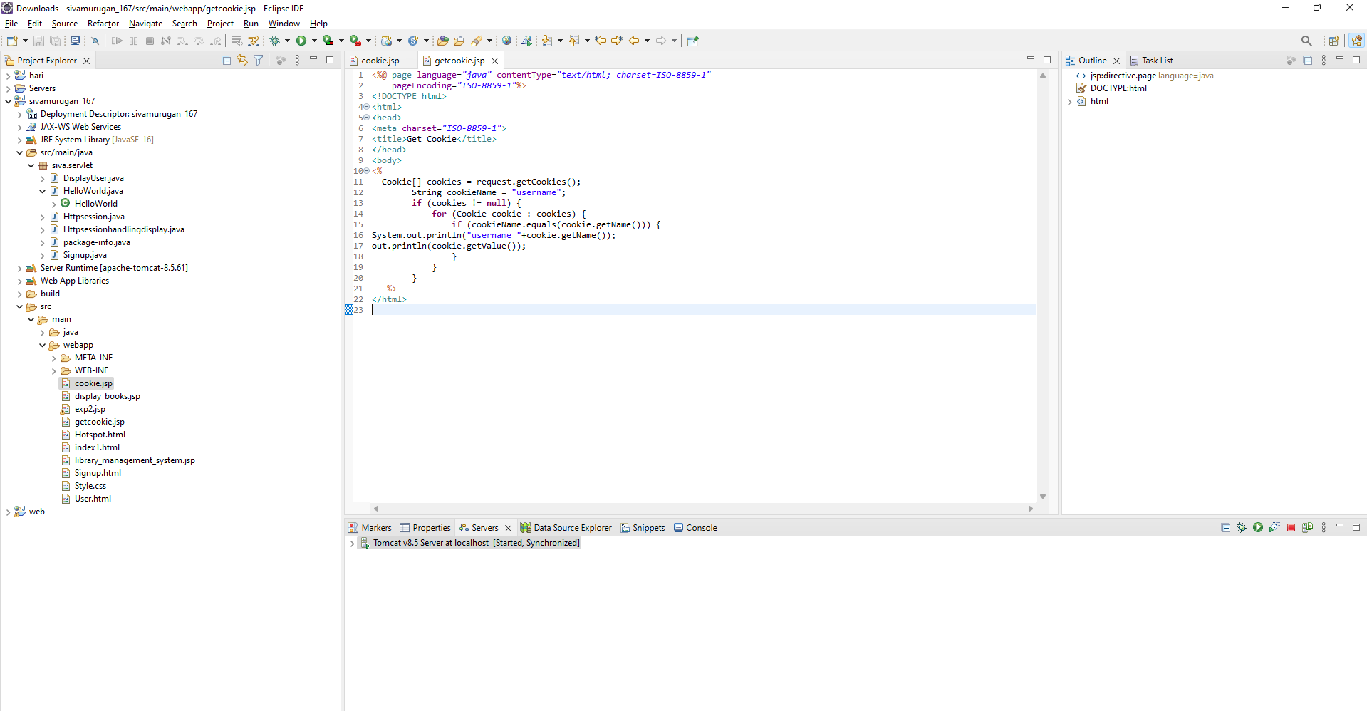

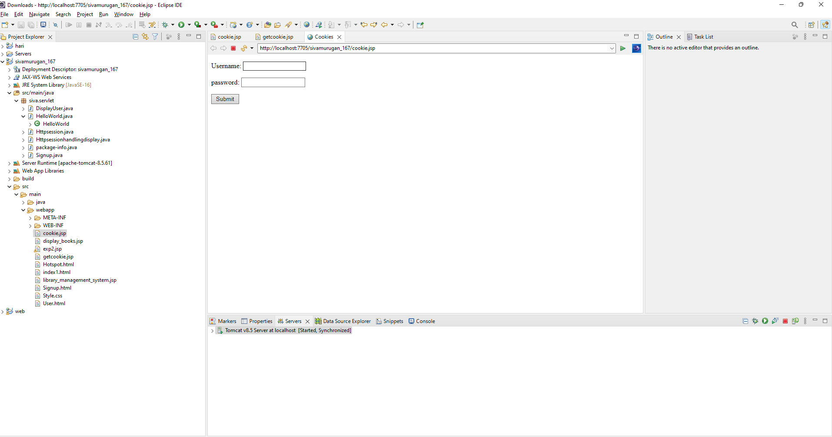

RESULT :
Thus the experiment Write a Servlet program to store a user's preferences (like theme or language) using cookies. Retrieve and display these preferences on subsequent visits has been successfully implemented and verified

